Egyptian-German archaeological fieldwork on Gebel Asyut al-gharbi (2016)
Preliminary Report
From 18th August 2016 to 5th October 2016, the Egyptian-German Mission from Sohag University, Freie Universität Berlin and Johannes Gutenberg-Universität Mainz conducted fieldwork in Gebel Asyut al-gharbi (Fig. 1).
Fig. 1
The work on Gebel Asyut al-gharbi was interrupted for three days (from 23.08.2016 to 25.08.2016) because of the intervention of the Egyptian military. One had to clarify the mission’s right to work on Gebel Asyut al-gharbi. Beginning with 27.08.2016, the mission continued the fieldwork on Gebel Asyut al-gharbi.
Participants of fieldwork were:
Prof. Dr. Jochem Kahl (project director; field director), Prof. Dr. Ahmed Alansary (field director), Prof. Dr. Ursula Verhoeven (project director), Prof. Dr. Mahmoud El-Hamrawi, Prof. Dr. Mohamed Abdelrahiem, Dr. Hesham Faheed Ahmed, Dr. Abdelnasr Yasin, Dr. Sameh Shafik, Dr. Teodozja Rzeuska, Dr. Ilona Regulski, Mohamed Alshafey, Adel Refaat, Eva Gervers, Andrea Kilian, Tina Beck, Alice Sbriglio, Chiori Kitagawa, Stephan Hartlepp, Ana Sofia Gomes, Fritz Barthel, Philipp Jansen, Aneta Cedro, Katarzyna Molga, Ewa Czyczewska.
Fieldwork focused on:
- Tomb I (P10.1), owner: Djefai-Hapi I (Dynasty 12): Cleaning of the causeway to the tomb was continued (Figs. 2-5). This causeway is already mentioned in the inscriptions of Tomb I: The ten contracts, which Djefai-Hapi made with the priests of the Wepwawet-temple and the Anubis-temple as well as with the personnel of the necropolis, mention a garden and the causeway. During the fieldwork, it became clear, that the causeway follows the direction to the old city of Asyut. The side walls of the causeway were built by hewn stones connected by gypsum mortar. The inner walls were originally covered with gypsum plaster, as some still existing plaster fragments show.
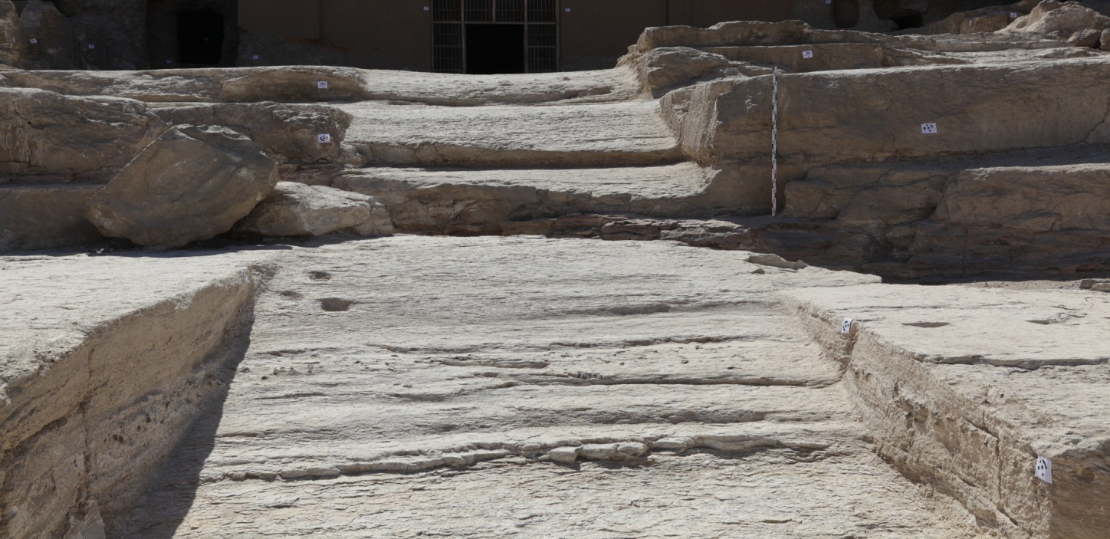Fig. 3
While cleaning the destroyed first hall, three shafts were uncovered (Figs. 6-7). One (shaft 6) is unfinished, another one (shaft 7) was already excavated at some time in the past, but still contained two complete vessels. The third shaft (shaft 8) is situated at the modern entrance gate and was already excavated by the British archaeologist Gerald Avery Wainwright in 1922. This shaft belongs to a man called Heny, who held the title “overseer of the house” (probably of Djefai-Hapi I).
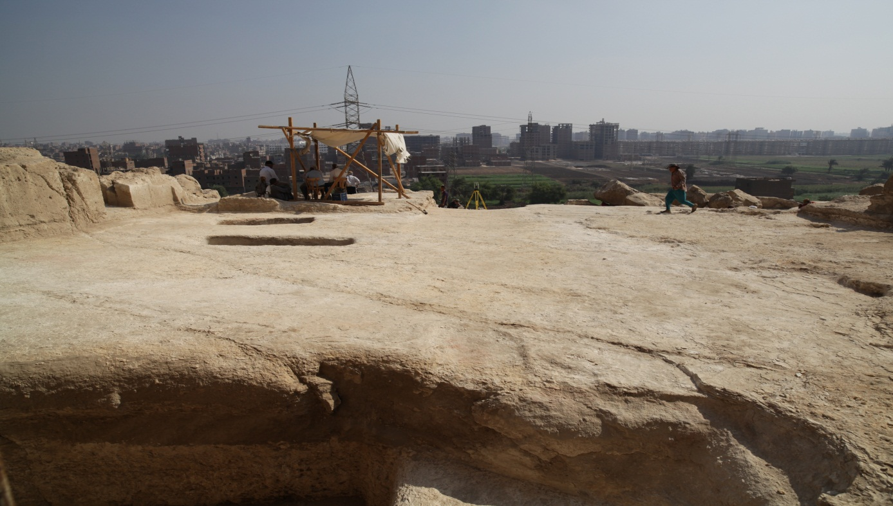
Fig. 6
Shaft 1 of Tomb P10.1 (Tomb I) was further cleaned of its filling, which consisted mostly of debris and larger stones (flintstones). The shaft, which is located in the inner hall inside Tomb I at the southern wall (south of the shrine), consists of the following architectural structures:

- A sloping passage leading to a first horizontal level with a vertical shaft (shaft 1.1) and a niche at the western edge of shaft 1.1.
- Shaft 1.1 leads to a second horizontal level underground, from which another shaft opens (shaft 1.2).
- There is a small side chamber in the north of shaft 1.2.
Fieldwork started with the cleaning of the southern part of shaft 1.1. The filling consisted at the beginning of grey debris with some finds and some larger stones, which were stored in the western niche of shaft 1. The cleaning stopped at the southern part of shaft 1.1, since the northern profile of this cut showed, that a karst formation within the shaft construction was reached. Only in the first layers ancient as well as modern remains were found. Within these finds a fragment of a wooden statue of a striding man can be highlighted (S16/ st 224). Also a large fragment of a basket (S16/st 214, 219) was found and it seems likely that the findings surrounding it, had been stored in it (including the wooden statue fragment). Due to the karst formations which were already visible in the western and southern walls of shaft 1.1, it can be assumed that the construction of shaft 1.1 stopped and another shaft was constructed to the east of it (shaft 1.2) (Fig. 8). This assumption is supported by the fact, that no finds (neither ancient nor modern) occurred within the darker debris of the karsts.
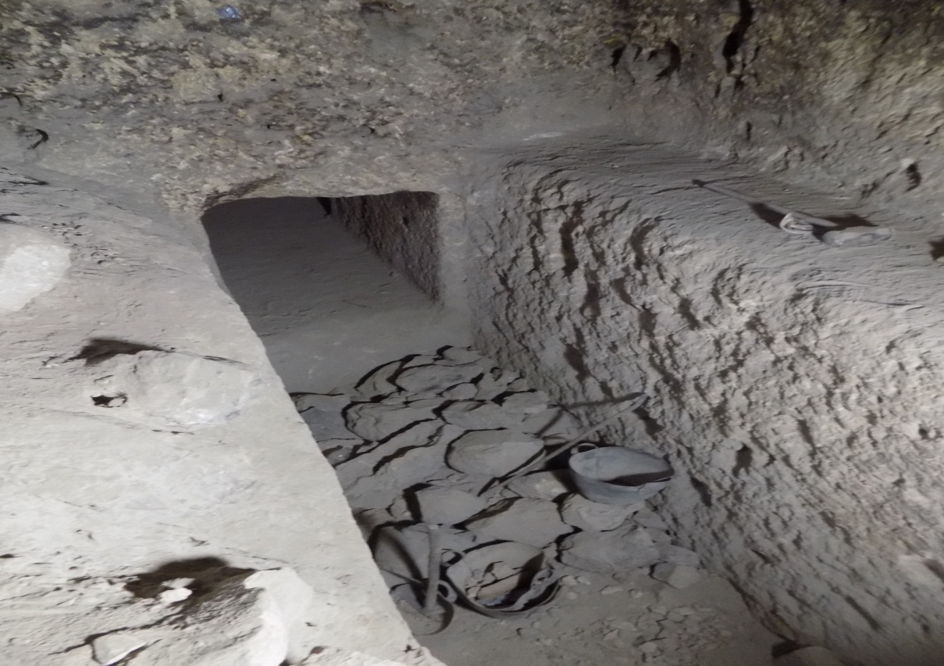
Therefore, the work continued in the east, where – under various large stones – the eastern edge of shaft 1.2 and the entrance to a small side chamber to the north of it were already visible. The cleaned area south of shaft 1.1 and the natural karsts of this area were used to store the large flintstones that filled the new shaft. The work continued here until the entrance of the northern chamber was fully accessible. The chamber was filled with some larger stones directly at its entrance and the floor was covered with 15 cm of dust. After cleaning the northern chamber the work continued in shaft 1.2 and came to an end on September 21th 2016.
The finds within the debris of shaft 1.2 as well as the northern side chamber contained among others fragments of pottery from the Middle Kingdom to the Islamic Period, worked wood from coffins or boxes as well as bandages and bones from humans and animals. Modern remains, like packaging, ropes and wooden beams, were also found.
The cleaning of shaft 1.2 stopped this season at 53,42 m aSL, which means half a meter above the modern street level. That means, the cleaning stopped at 21,38 m underneath the floor of Tomb I.
The underground construction of Tomb I seems to imitate the underworld. This assumption corresponds to Djefai-Hapi’s well known leading role in the Osiris cult at Asyut.

In addition, epigraphic work was conducted in the tomb: Restorers cleaned walls in the Great Transverse Hall as well as a small part on the ceiling of the First Corridor. Here, the ceiling decoration with blue stars on yellow ground became clearly visible. Also facsimiles of the walls of the Great Transverse Hall were collated.

- Tomb V, owner: Khety I (First Intermediate Period): Tomb V was built by the Asyuti nomarch Khety I. Between 1825 and 1828, the tomb was blown up by dynamite due to stone quarrying activities. The tomb’s front and ceiling as well as tombs which were built above Tomb V higher up in the mountain collapsed. Since then, heavy stones and debris have covered the tomb. Since several years the Egyptian-German mission has been cleaning the tomb. A part of the entrance area of the tomb was cleaned this season. Fragmented parts of the original tomb inscription (damaged by the explosion in c. 1825-1828) could be found (Fig. 9). To the south of the tomb’s entrance several layers of a plastered floor (probably from Roman or Byzantine Period) were detected. In addition, epigraphic work was conducted in the tomb and restorers cleaned the tomb walls.

- Tomb IV, owner: Khety II (First Intermediate Period): The architecture in Tomb IV was recorded. The tomb is unfinished: Only the tomb shafts, the autobiographical inscription on the front section of the northern wall, and the front row of pillars were finalised.

- Tomb M12.3: Epigraphic work was also conducted in Tomb M12.3 (owner: the deputy Khety; time of Senwosret III or Amenemhet III) (Figs. 10-11). This tomb contains the last known reference to an Asyuti nomarch dating from the Middle Kingdom. Egyptologists had been aware of Tomb M12.3’s existence since the French Expedition, but its exact whereabouts were unknown. Research under the aegis of the Asyut Project has led to the rediscovery of the tomb. The biographical inscription on the east wall was collated. Restorers cleaned a part of the ceiling and of the decoration.

- Stage 3: A row of smaller tombs is situated to the south and above Tomb I (Figs. 12-13). This area corresponds to the geological stage 3 of Gebel Asyut al-gharbi. It was already excavated by the Italian archaeologist Ernesto Schiaparelli before World War I. According to the study of archival material in the Turin National Archives. It is highly probable that Schiaparelli worked here in 1908. The architecture of several tombs was recorded and ground plans generated. Even if already excavated and heavily damaged by wind and weather, the location of the tombs allows to reconstruct, where high Asyuti First Intermediate Period and Middle Kingdom officials, such as Min-hotep, were buried.

- Animal bones (especially rams), which were found during the last seasons in the so called Northern Soldiers Tomb, were studied. Most of them were deposited in a side chamber in the southern wall of the tomb. Cranial as well as postcranial bones were present in the assemblage, which means that the animals were deposited in complete condition. Apart from sheep there were a few dog bones.

- In addition, the mission studied objects from Gebel Asyut al-gharbi on the mountain itself as well as in the magazine of the Ministry of State for Antiquities at Shutb. Pottery and Coptic ostraca were mainly studied. The study of the material for a PhD thesis on First Intermediate Period / early Middle Kingdom pottery was completed.

- Three objects from the 2016 season were stored in the MSA/SCA-magazine at Shutb and registered in the registerbook (Figs. 14-16). These objects are complete vessels (pottery): SCA 285 (vessel from Tomb V; height: 6 cm; diameter of rim: 11,5 cm); SCA 286 (vessel from Tomb I, shaft 7; height: 13,3 cm; diameter of rim: 7,8 cm); SCA 287 (vessel from Tomb I, shaft 7; height 9,0 cm; diameter of rim: 8,5 cm).

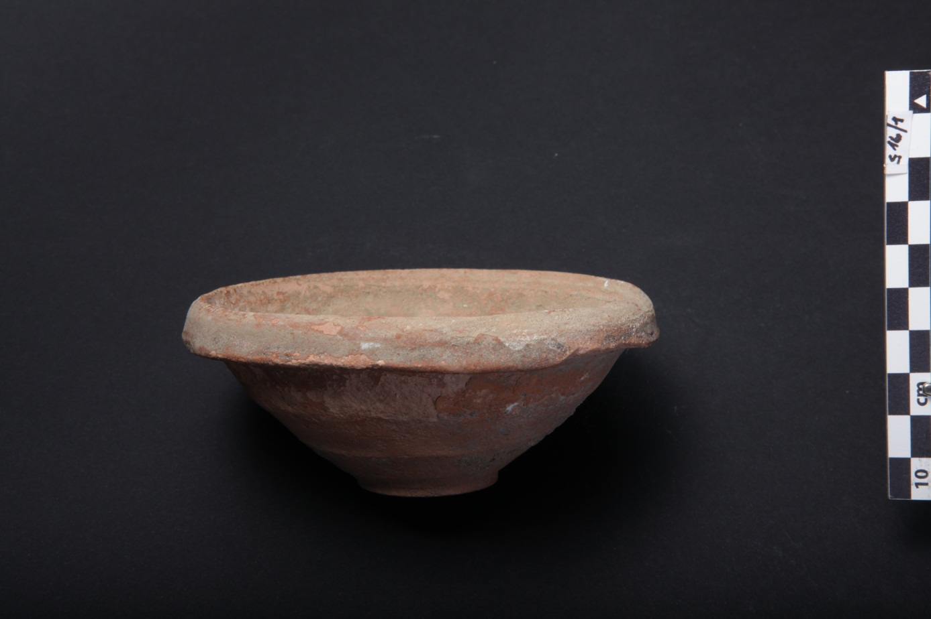
Fig. 14

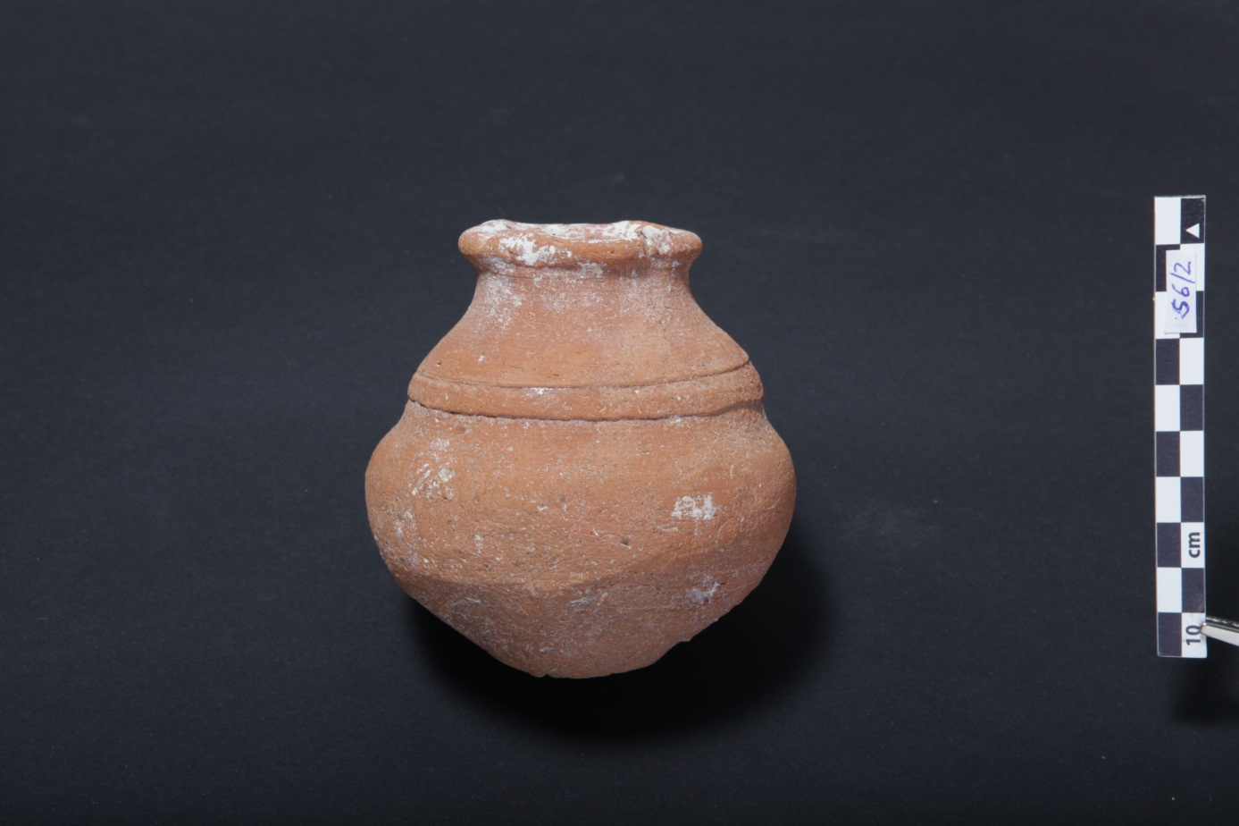
Fig. 15

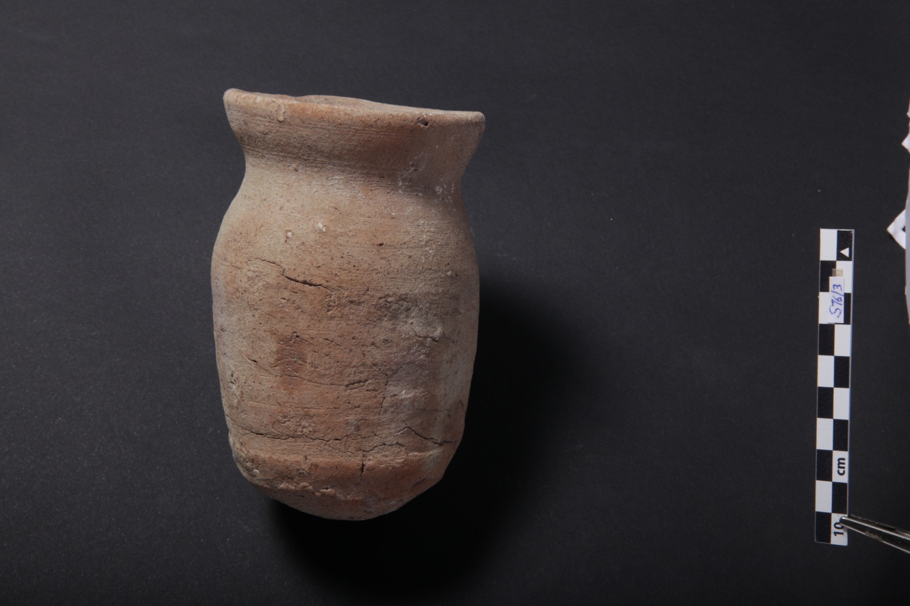
Fig. 16

